|  |
| --- |
| **Argentis Consulting** |
| **Apparel & Footwear** |
| Crystal Reports Installation Process 1.2 |



**www.sapapparel.com**

INDEX

1 ODBC Connection 3

1.1 SQL 3

1.2 HANA 3

2 Download Crystal Files 4

3 SAP B1 Client Configuration 4

Crystal Reports Installation Process

The following steps describes the installation process of the Crystal Reports in Apparel and Footwear.

To install the Crystal Report of Apparel and Footwear please follow the steps:

# ODBC Connection

A new System ODBC connection has to be created. Name the ODBC CRHANA (this is compulsory) and use a default database.

Go to: Control Panel\All Control Panel Items\Administrative Tools

NOTE: If your Operative System has two ODBC Data Sources for different bit platforms like in the picture below, create the connection in both of them. If you have only one, create only one.

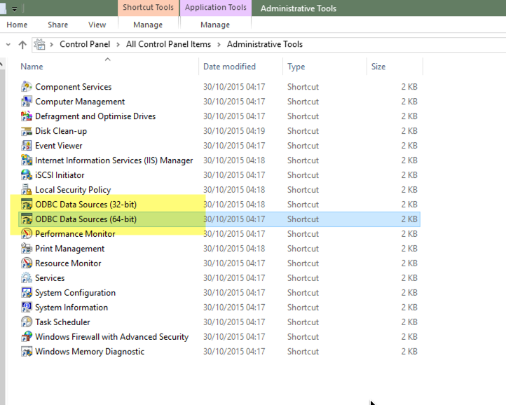

After creating the ODBC connection and opening any of the ODBC Data Sources you should see the same connector but with different platforms.

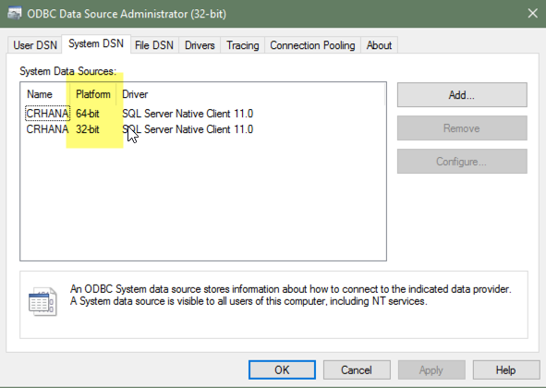

## SQL

For SQL create a new ODBC connection manually.



## HANA

If the implementation is on HANA environment create using the following driver





# Download Crystal Files

1. If you were given a user and a password to access to the FTP, download the Crystal files in: <http://om.argentisconsulting.com/Apparel/Releases>. If not, ask to support@argentisconsulting for the Reports.
2. Save the .zip file in the Server Shared Folder. Default path is: ServerIPOrAlias\Program Files (x86)\SAP\SAP Business One Server\B1_SHR\Crystal
3. Click on Unrar here. A new folder will be created named “Reports”
4. Click on the folder mentioned above and then open the CommandReports folder
   1. SQL
      1. Copy all the files inside the SQL folder
   2. HANA
      1. Copy all the files inside the HANA folder
5. Paste the copied files in the folder “Reportes”. If a window pops up, click on “Replace them all”.

# SAP B1 Client Configuration

1. In SAP go to Apparel and Footwear 🡪 Administration 🡪 Setup 🡪 General Settings 🡪 Sheet Path. Repeat the locations in the field Crystal Report.

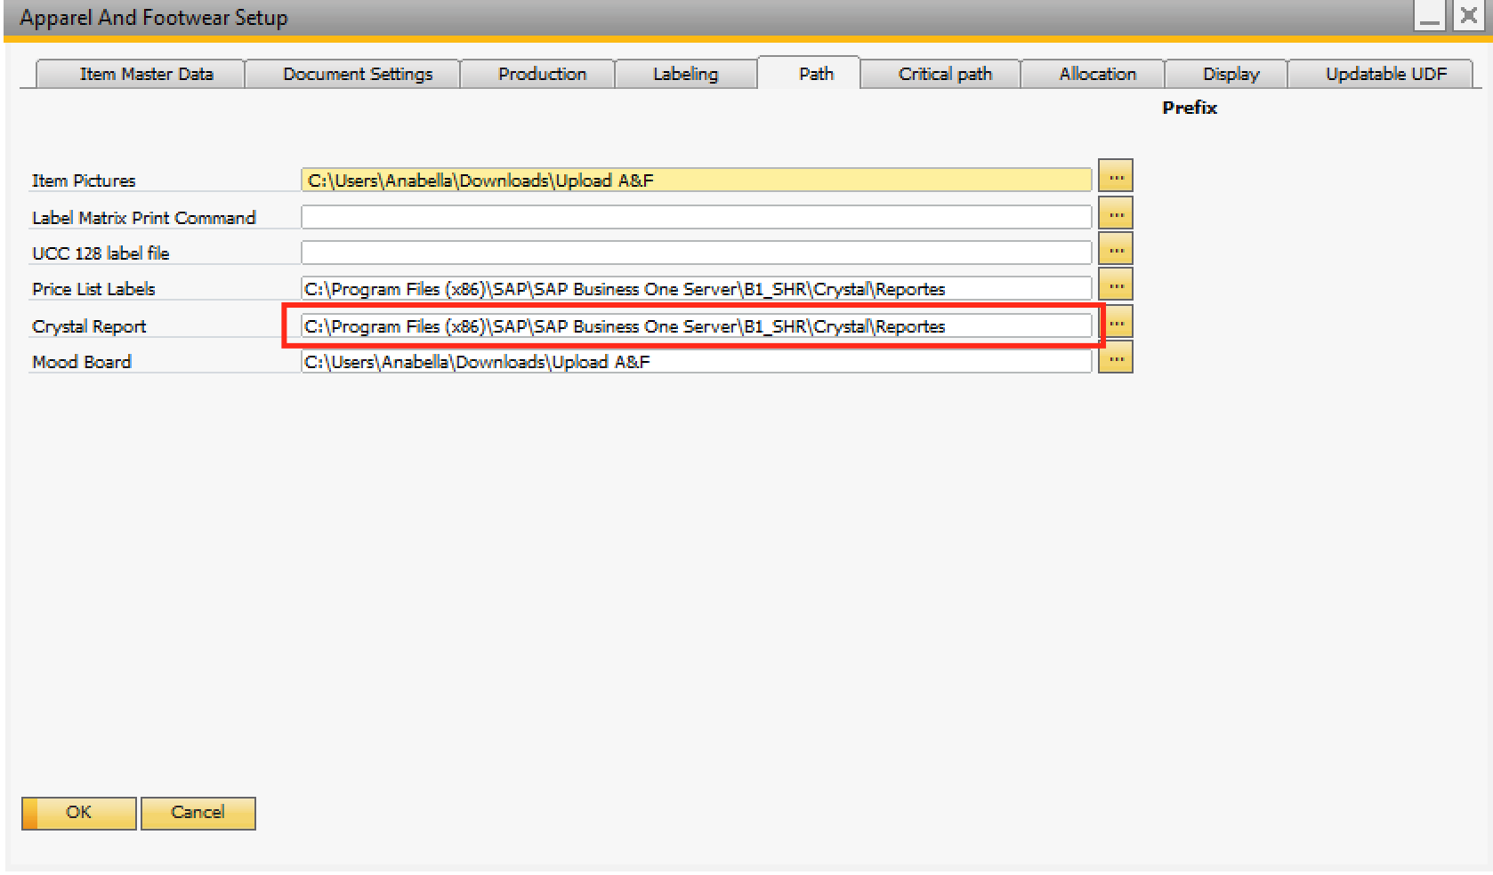

1. Register the crystal reports. Please go to: Apparel and Footwear / Administration / Setup / Maintenance. Select the option “Register ActiveX”.

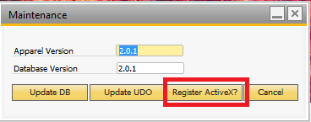

**Note: Each time the version of Apparel and Footwear is update, this last step should be repeated.**



**www.argentisconsulting.com**

**Argentis Consulting** is dedicated to the development, distribution and support of recognized certified solutions for SAP Business One, as an SSP (Software Solution Provider) with a Gold Partner status.

**CONTACT INFORMATION**

|  |  |
| --- | --- |
| **USA**  9744 NW 45th Lane  Doral, FL 33178  info@argentisconsulting.com | **ARGENTINA**  Ávila y Zarate 2048  Cerro de la Rosas, Córdoba,  CP 5009  Córdoba - Argentina  info@argentisconsulting.com |
| **CARIBEAN**  City View Plaza – Suite 301  48 Road 165  Guaynabo, PR. 00968  Puerto Rico  caribe@argentisconsulting.com | **SPAIN**  C/ Juan Bravo N° 3 A 28006  Phone: (+34) 91 123 7263  Madrid - Spain  info@argentisconsulting.com |